

**User Manual**

**Product Model**

A20-CL

Version v1.4.0.X(SG)

|  |  |
| --- | --- |
|  | SwiftMR  User Manual, English  A20-CL-UM-SG-EN Revision 1 (2023-08)  ©2023 AIRS Medical Inc.  All rights reserved. |

**Contents**

1. Introduction 4

1.1. Product Overview 4

1.2. Intended Use 5

1.3. Intended Patient Population 5

1.4. Intended Users 5

1.5. Contraindication 5

1.6. Intended Use Environment 5

1.7. Storage Condition 5

1.8. Medical Indication 5

1.9. Supported MR and PACS devices 5

1.10. Limitations 5

1.11. Functionalities 6

1.12. Minimum Requirements for the Software Operating Environment 6

1.13. Labeling 6

1.14. Symbols Glossary 7

1.15. Cautions 7

1.16. Abbreviations 8

2. Functions 9

2.1. Login and Logout 9

2.2. Automated Logout 10

2.3. Main Page 11

2.4. Image Processing Availability 13

2.5. Image Processing Status 14

2.6. Toast Message 14

2.7. Settings 16

2.7.1. General Settings 16

2.7.2. Quality Check (QC) Settings 17

2.7.3. Appearance Settings 18

2.7.4. Profile Settings 19

2.7.5. Device Settings 20

2.7.6. Scan Item Settings 21

2.7.7. Info Settings 23

3. User Account Management 25

4. MR Scans and Image Processing 25

4.1. MRI Scans 25

4.2. Image Processing 25

5. Cybersecurity 25

6. Trouble Shooting 26

7. Maintenance 28

8. Quality Assurance 28

**Thank you for using AIRS Medical’s Product.**

AIRS Medical Inc. is a company devoted to developing products that exceed customer expectations as well as meet the relevant standards and legal requirements by aiming for world-class excellence in all tasks we perform.

This user manual provides instructions for using SwiftMR, including warnings and cautions to prevent hazardous situations. Please read this User Manual thoroughly before use.

**Homepage**

For more information about AIRS Medical and our products, please visit us at [www.airsmed.com](http://www.airsmed.com) .

**General Information**

* 『SwiftMR』 is a registered trademark of AIRS Medical Inc.
* The content of this User Manual is protected by copyright. If the content of this User Manual is modified or distributed without the written consent of AIRS Medical Inc., you will be liable for legal responsibilities.
* User manuals for SwiftMR are provided in electronic forms (eIFU). Internet connection is essential to access the eIFU.
* AIRS Medical Inc. may change or modify the specifications of the product and the contents of the manual without prior notice.

# Introduction

## Product Overview

SwiftMR provides automated image quality enhancement for MR images acquired from various environments. This device should be used only for professional purposes.

SwiftMR’s automated processes are as follows:

* Uploading MR images in DICOM format after completions of MR scans
* Enhancing image quality using deep learning model
* Downloading enhanced MR images in DICOM format

Integration of PACS inside the institution with the manufacturer’s Cloud server is necessary at the first installation of this product. Afterwards, SwiftMR performs image processing in the background automatically and provides logged in users the authorization to use functions and view image processing results in a worklist format through Client Application.

The figure below depicts the overall architecture of SwiftMR.

* 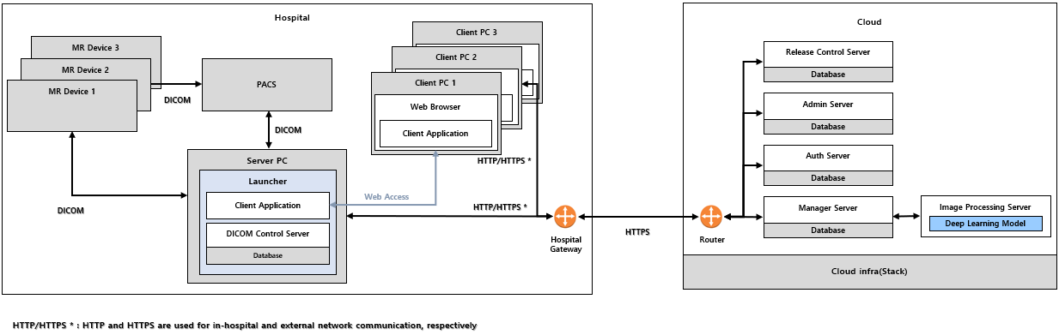

## Intended Use

SwiftMR is a stand-alone software solution intended to be used for acceptance, enhancement and transfer of brain, spine, knee, ankle, shoulder, and hip MR images in DICOM format. It can be used for noise reduction and increasing image sharpness for non-contrast enhanced MR images.

SwiftMR is not intended for use on mobile devices.

## Intended Patient Population

Adults over 21 years of age

## Intended Users

**Health care professionals** (trained radiologic technologists)

* User should have experience with operating a software User Interface based on PC (including MRI and PACS)

## Contraindication

None.

## Intended Use Environment

This product is to be used in the following care area:

• MRI room

## Storage Condition

SwiftMR is stored on a Cloud server.

## Medical Indication

Patients with clinical conditions that need MR imaging of brain, spine, knee, ankle, shoulder, or hip.

## Supported MR and PACS devices

The scope of MR devices supported by SwiftMR is as follows:

• Manufacturers: GE, Philips, Siemens

• Field Strength: 1.5T / 3.0T

• MR device models: All 1.5T / 3.0T models of the above 3 companies are supported

The scope of PACS devices supported by SwiftMR is as follows:

• All DICOM-compliant PACS devices can communicate

## Limitations

SwiftMR is only available in certain countries.

This product meets the HAS requirement for medical device software.

## Functionalities

* Worklist view
  + Search by Scan date
  + Search by Patient name and/or Patient ID
  + Search by Modality
  + Search by Body part
  + Search by Status of image processing
* Image processing
  + Import acquired MR images from PACS/MR Device
  + Enhance image quality
  + Download the enhanced MR images to PACS/MR Device

## Minimum Requirements for the Software Operating Environment

|  |  |  |
| --- | --- | --- |
| Item | Launcher | Client Application |
| OS | Microsoft Window 10 64 bit | N/A |
| Hardware | CPU: Intel i3 and above  RAM: 4GB and above  Storage: 250GB available | N/A |
| Web Browser | N/A | Google Chrome 92.0.4515 version or later  Microsoft Edge 92 version or later |
| Network | Ethernet-based Intranet/internet connection | |
| Monitor | N/A | 1600X900 resolution with 8-bit color |

## 

## Labeling

|  |  |
| --- | --- |
| Symbol | Definition |
|  | ‘User Manual’ reference symbol. This product is provided with the electronic instructions for use (eIFU). After accessing AIRS Medical’s eIFU homepage (https://airsmed.com/eifu/), you can download the user manual within each countries’ page and read it via PDF Reader. |

## Symbols Glossary

Symbols used in this user manual is as follows. Please familiarize yourself with the symbols in the table below.

Warnings, cautions and notes are for the correct and safe usage of the product. Please be advised of all the following for safety. AIRS Medical Inc. is not responsible for failures due to negligence of safety warnings and cautions.

|  |  |
| --- | --- |
| Symbols | Meaning |
| **Note** | Indicates useful information about features of the software. |
| Caution | Indicates potentially hazardous situations for the patient or user that could result in lost time, reduced image quality and/or re-examination of the patient. |
|  | Indicates potentially hazardous situations that could result in direct or indirect patient injury, mainly in the form of misinterpretation or misdiagnosis. |
|  | Manufacturer. The symbol is accompanied by the name and address of the manufacturer. |
|  | e-IFU (electronic-Instructions for Use)  The link that directs users to this user manual is alongside the symbol. |
|  | Catalog number |
|  | Lot number. Version number of the software. |

## Cautions

* **Warning**
  + SwiftMR is designed for trained radiology technologists. Those who are not trained should not use this product.
  + Images that have already been quality-enhanced should not be processed again. This may cause damage to the images.  
    
* **General Caution**
  + Installation, maintenance, and repair of SwiftMR must only be done by engineers qualified and certified by AIRS Medical Inc.
  + Operation and maintenance of SwiftMR strictly follows the user manual. Please preserve this user manual well.
* **Caution for Use**
  + Check before use to see if the Quality Check, that the system conducts automatically at a specified time each day or conducted manually, has successfully been completed.
  + Do not turn off the power of the PC or programs during use.
  + After use, be sure to log out of the program.

## Abbreviations

The following is the definitions of the abbreviations used in this User Manual.

|  |  |
| --- | --- |
| DICOM | Digital Imaging and Communications in Medicine |
| MRI | Magnetic Resonance Imaging |
| PACS | Picture Archiving and Communication System |

# Functions

Client Application can be accessed through Google Chrome or Microsoft Edge browser in the hospital where SwiftMR is installed. You can access it through *[SwiftMR server’s IP address in the hospital]: 50000/swiftmr-client*.

The main functions of the Client Application are as follows.

## Login and Logout

You need to login to use the main functions of SwiftMR.

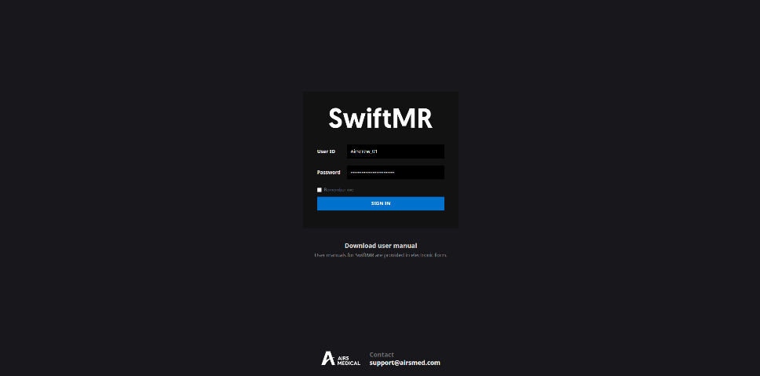

* **Login:** Enter ID and password provided by AIRS Medical and then click **SIGN IN**. When login succeeds, the main page of SwiftMR will appear.
* **Logout:** You can log out from SwiftMR to prevent unauthorized access by clicking the Logout button (). When logout succeeds, you will be directed to the login page.
* **User Manual:** You can access the e-IFU download page of AIRS Medical by clicking on the “Download user manual” button ().

|  |  |
| --- | --- |
| Note | Note: User account is created by AIRS Medical. After an account is created, you will be able to use it after resetting the password upon first login. |
|  | **Caution:** If login fails because an invalid ID or password was entered into the input field, an error message will show up. If you forget your ID or password, contact Customer Support ([support@airsmed.com](mailto:cs@airsmed.com)). |
|  | **Caution**: SwiftMR does not allow simultaneous logins of the same account. If you try to login to an already logged-in account, the previously accessed session will be terminated. |
|  | **Caution:** When login attempts fail 10 times, the user is restricted from login for the next 5 minutes. |
|  | **Caution:** Please contact Customer Support ([support@airsmed.com](mailto:cs@airsmed.com)) if you cannot access the eIFU download page. |

## Automated Logout

Users inactive for a certain period will be automatically logged out from SwiftMR to prevent unauthorized access. In the event of an automated logout, a Toast Message will appear and the screen will return back to the login page.

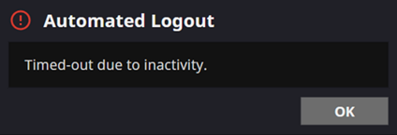

The Toast Message for automated logout disappears after a certain period..

## Main Page

Main page of SwiftMR is constructed as follows:

* SwiftMR loads the list of acquired MR images from the connected PACS and display it in a worklist format.
* Users can easily search for an image of interest, and view detailed information, processing status, and processing results of the listed MR images from the worklist that is updated periodically.
* Users can check image processing results of each MR image in the Detailed Info section.
* Also, at the bottom of the main page, the license expiration, current usage, and maximum usage can be viewed.

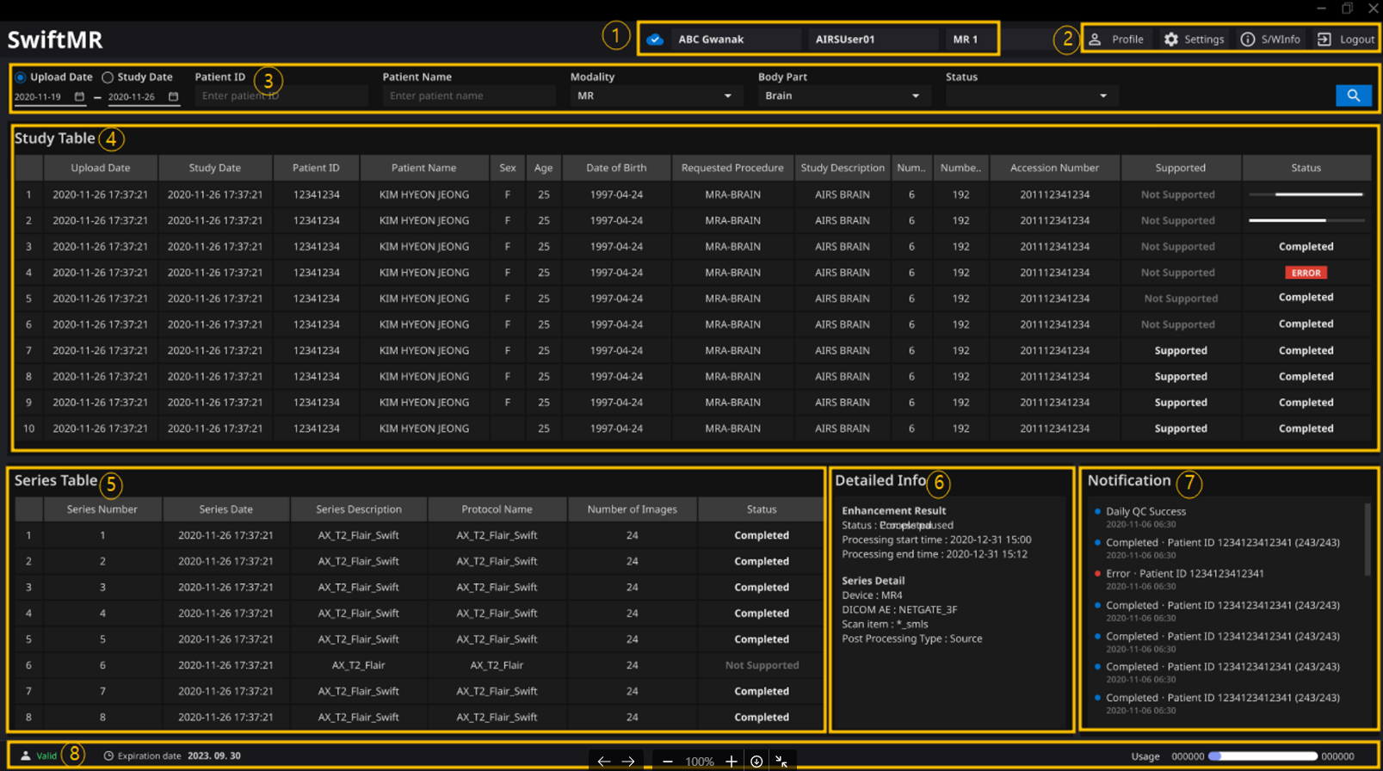

Detailed functions are as follows.

|  |  |  |  |
| --- | --- | --- | --- |
| No | Function | Item | Description |
| 1 | Status Bar |  | Network connectivity status (Blue: Connected, Red: Disconnected, Grey: Connectivity Check Unavailable) |
|  | Institution name |
|  | Name of the accessed user |
|  | Name of the connected MR device(s) |
| 2 | User Menu |  | User Profile |
|  | Software settings |
|  | Software information |
|  | Logout |
| 3 | Filter/Search | Data Range | Function to search the worklist by date range. |
| Patient ID | Function to search the worklist by patient ID |
| Patient Name | Function to search the worklist by patient name |
| Modality | Function to search the worklist by modality |
| Body Part | Function to search the worklist by body part |
| Status | Function to search the worklist by image processing status |
|  | Button to execute the search by the selected conditions |
| 4 | MR Study Table | Upload Date | Upload scan date (Year-Month-Day) |
| Study Date | Study scan date (Year-Month-Day) |
| Patient ID | Patient ID |
| Patient Name | Patient name |
| Sex | Patient sex |
| Age | Patient age |
| Date of Birth | Patient date of birth (Year-Month-Date) |
| MR Device Name | Name of the MR device that created the study (based on SwiftMR registration) |
| Requested Procedure | Requested procedure |
| Study Description | Name of study protocol |
| Number of Series | Total number of series in a study |
| Number of Instances | Total number of images in a study |
| Accession number | Unique identification number of each image |
| Supported | Image process support |
| Status | Image processing status   * In Progress * Completed * Error |
| 5 | MR Series Table | Series number | Sequence number of the series within the study selected from the study table |
| Series Date | Scan date of each series |
| Series Description | Detailed description of the scanned sequences for each series |
| Protocol Name | Protocol name of the scanned sequences for each series |
| Scan Item Name | Protocol name of the sequence registered in SwiftMR |
| Number of Images | Total number of images in a series |
| Supported | Image process support |
| Status | Image processing status of the series |
| 6 | Detailed Info | Enhancement Result | Enhancement result   * Status: Completed, Error * Processing start time * Processing end time |
| Series Detail | * Device: MRI equipment name images are stored in * DICOM AE: PACS name images are stored in * Scan Item: Sequence protocol information registrered in SwiftMR * Post Processing Type: Post processing type in the case of post processing images |
| Error Detail | * Code: Error code * Message: Error Message * RetryCount: Number of retries attempted |
| 7 | Notification | Notification | Notification window displaying image processing status, Daily QC results, etc. |
| 8 | Contract Information Status Bar |  | Contract End Date |
|  | Current Usage and Maximum Usage |

|  |  |
| --- | --- |
|  | Caution: The network connection status icon shows the connection between the institution’s network and the cloud server of SwiftMR. If a problem occurred with the internet connection of the PC running the software, you will not be able to check this through the network connection status icon, and you will be automatically logged out. |
|  | **Warning**: When network connection status icon is marked red or grey, it may cause problems regarding image processing. Resolve the problem as soon as possible by contacting **AIRS Medical** or the manufacturer. |
|  | **Caution**: Worklist displays only the acquired MR images from the selected MR devices. Therefore, when you cannot find the desired study in the worklist, check the selected MR devices. |
|  | **Caution:** Personal information stored in SwiftMR is anonymized 24 hours after registration. Use the PACS Viewer to inquire patient information about MR studies processed by the product. |

## Image Processing Availability

* Image processing availability is classified as follows.

|  |  |
| --- | --- |
| Icon | Description |
|  | **Image Processing - Supported**   * **Study Table:** If there is at least one SwiftMR-supported series among the series in the applicable study, the “Supported” icon will be displayed. * **Series Table:** If the series is supported by SwiftMR, then the “Supported” icon will be displayed. |
|  | **Image Processing – Not Supported**   * **Study Table:** If there is no SwiftMR-supported series among the series in the applicable study, the "Not Supported" icon is displayed. * **Series Table:** If the series is not supported by SwiftMR, then the “Not Supported” icon will be displayed. |

## Image Processing Status

* Image processing status is classified as follows.

|  |  |
| --- | --- |
| Icon | Description |
|  | **In progress**  Image processing progress is indicated with a progress bar |
|  | **Completed**   * **For Supported Studies:** Indicates that image processing has been completed and that the processed images are successfully stored to the selected DICOM AE (PACS, MR Device). * **For Not Supported Studies** Indicates that unsupported images are successfully stored to the selected DICOM AE (PACS, MR Device). |
|  | **Error**  An error occurred during image processing. |

## Toast Message

Users are notified of significant processing results with a toast message and through the Notification section. Toast message for each situation are as follows:

|  |  |
| --- | --- |
| Toast Message | Description |
|  | Image processing complete. |
|  | Image processing failed. |
|  | Automated logout. |
|  | End Date and Usage Expiration |

|  |  |
| --- | --- |
|  | Caution: Toast messages for the image processing results are only displayed for the connected MR devices. If images that are scanned through a desired device cannot be viewed, check the device setting in Settings → Device. |
|  | **Caution**: Toast message for image processing and image processing history in the Notification section is only shown for the connected MR devices. Therefore, if toast message for a desired study does not show up, please reset the device for which you want to be notified through the device settings in Section 2.7.5. |

## Settings

). Users can set various environment settings related to software operation in the software settings window. Software settings of the user consists of General, QC, Appearance, Profile, Device, Scan Item, and Info tabs.

### General Settings

* **Auto logout time settings:** User can set the automated logout time from the General tab of Settings. Choose the time of the inactive period in which automated logout will occur afterwards from the drop-down menu and click on the **SAVE CHANGES** button.

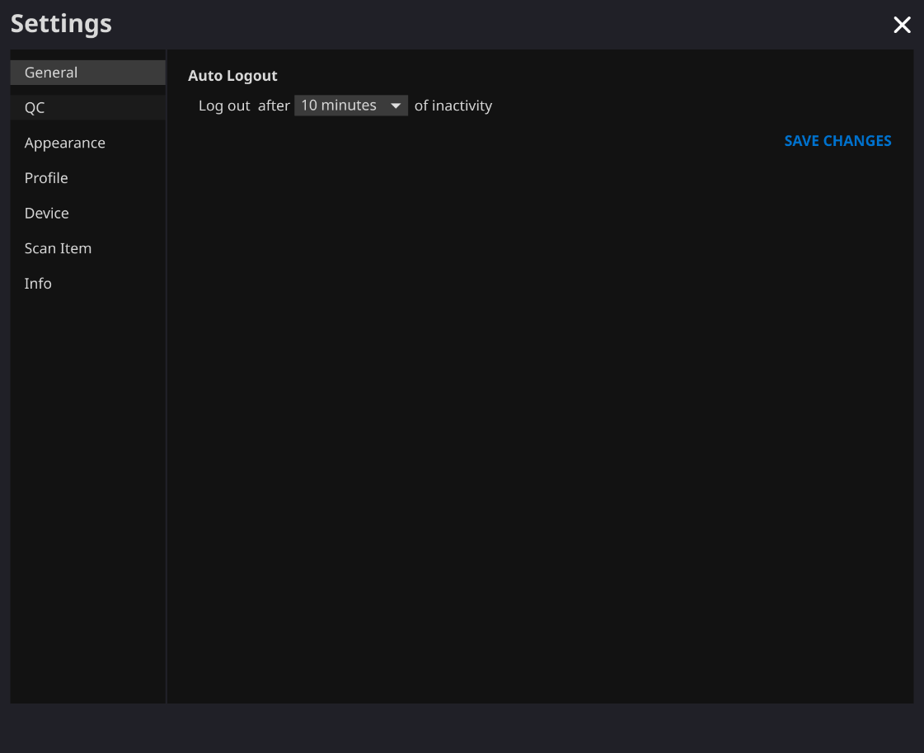

### Quality Check (QC) Settings

* User can view the Quality Check settings and the results from the QC tab of Settings
  + **QC Status:** User can check the results and time of the most recently performed QC.
  + **Daily QC:** User can check how the QC time is set.
  + 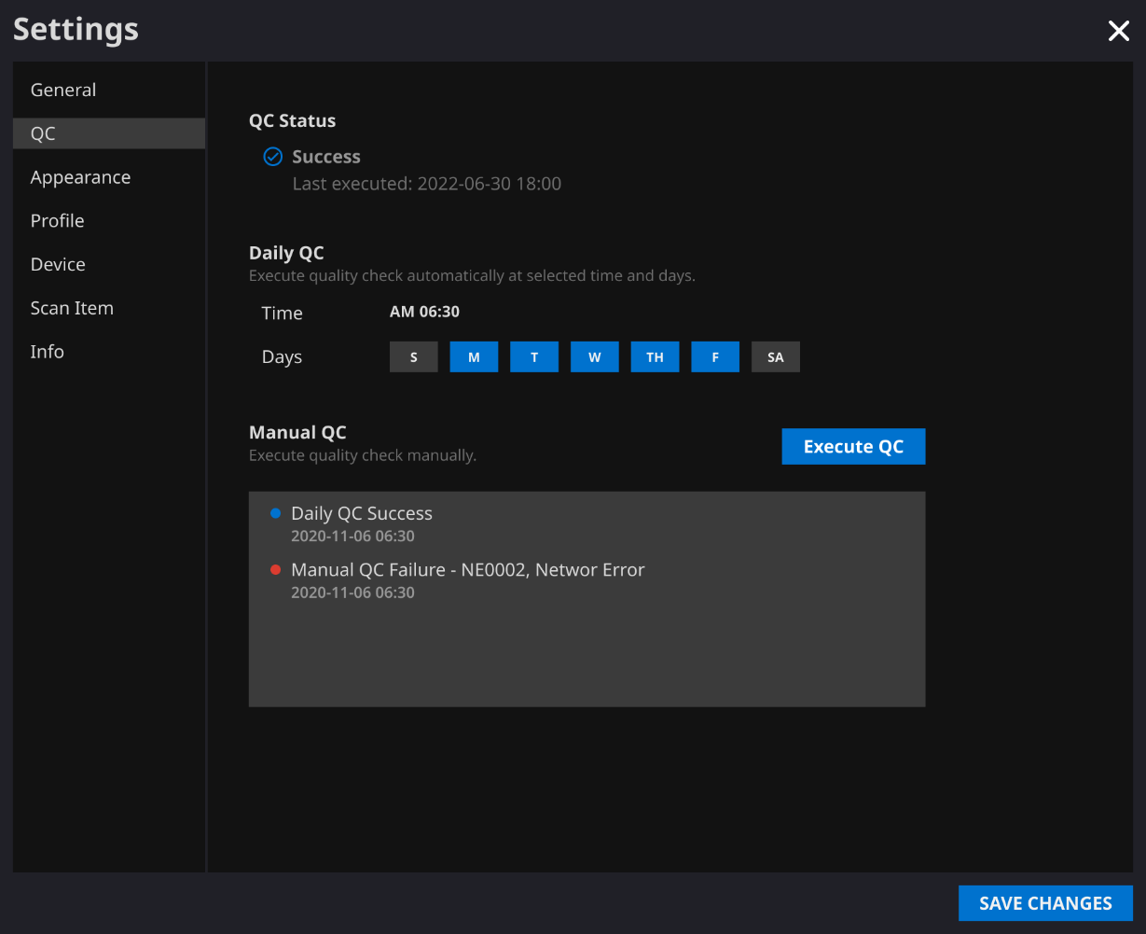**QC Logs:** User can view the notifications regarding QC results.

### Appearance Settings

* User can set the appearance of the main page from the Appearance tab of Settings.
  + **Font**:   
    Size – Choose from Small, Medium, and Large  
    Weight – Choose between Normal and Bold
  + **Table:** Select the columns to be shown in Worklist Table.
* After establishing the settings, click on the **SAVE CHANGES** button.

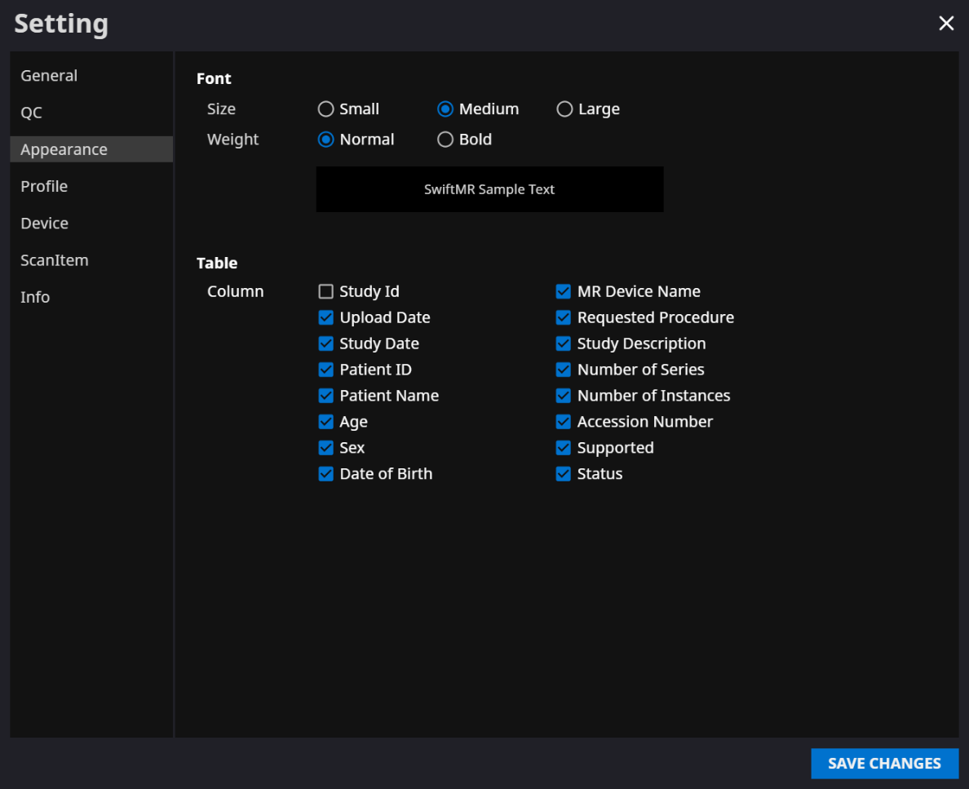

### Profile Settings

* User can view or modify his/her own profile by clicking on the Profile button (  ) or from the Profile tab of Settings.
* User can access the password change page through the password change button (Text

  Description automatically generated with medium confidence) and change the user’s password from the password change page.
* After establishing the settings, click on the **SAVE CHANGES** button.

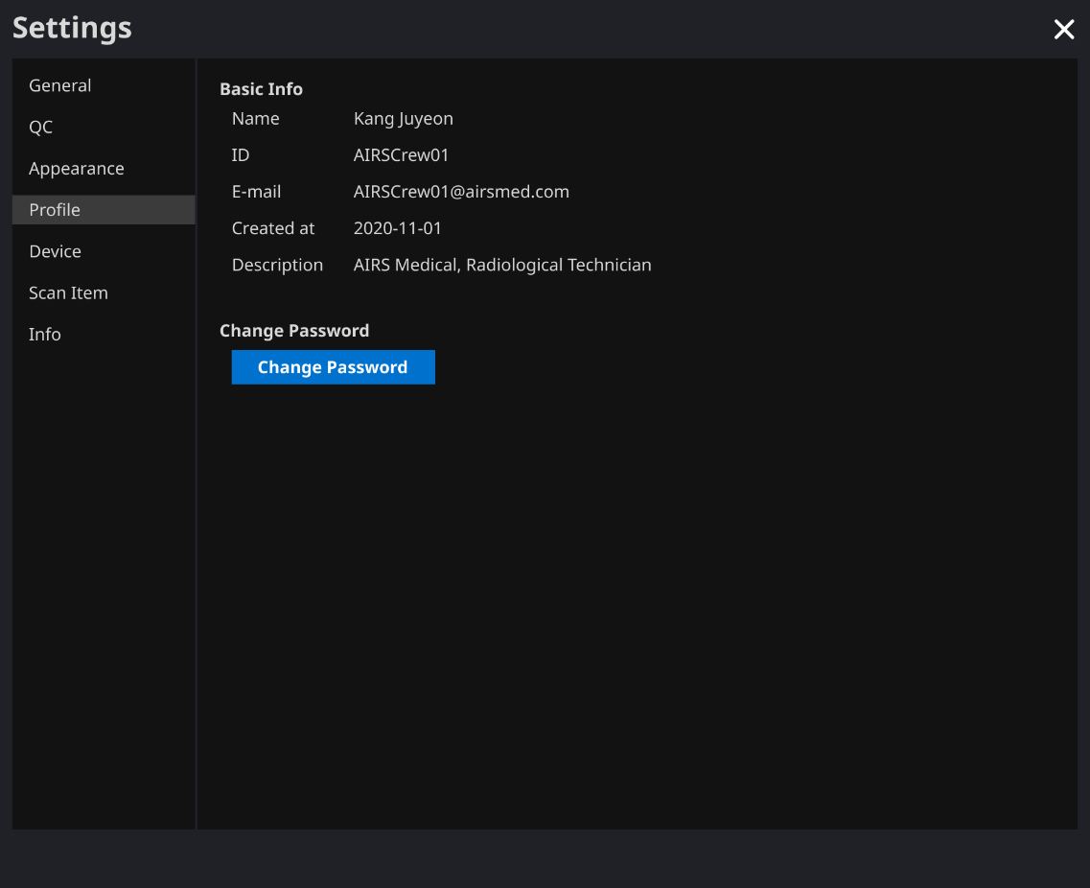

|  |  |
| --- | --- |
|  | Note: Password must satisfy the password policy of having at least 8 characters including 1 letter, 1 number, and 1 special symbol. |

### Device Settings

* Users can select the MR devices to receive notifications for image processing results among the list of registered MR devices from Device tab of Settings.
* All registered MR devices are selected by default.
* **Unselect**: Uncheck the device and click **SAVE CHANGES**.
* **Select**: Check the device and click **SAVE CHANGES**.
* After establishing the settings, click on the **SAVE CHANGES** button.
* Contact Customer Support ([support@airsmed.com](mailto:cs@airsmed.com)) to modify device settings.

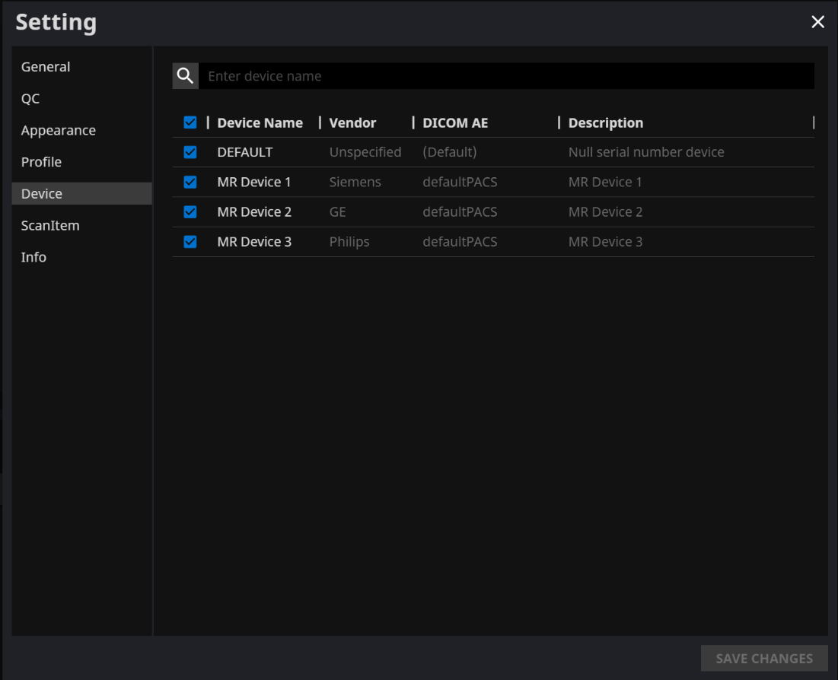

|  |  |
| --- | --- |
|  | Note: Each user can select multiple MR devices to receive notifications for. |

### Scan Item Settings

* Users can view the SwiftMR image processing standard protocols, set for the applicable MR Device by selecting the desired device in the Scan Item tab of Settings.
* SwiftMR takes the Protocol Name of an MR image to decide whether to process it. When processing is required, the enhancement will follow the Swift Model predefined in the Protocol setting.
* The Denoising Level and Sharpness Level to be applied during the image quality improvement process can be set through Customer Support.
* Please check the protocols for image processing before using SwiftMR.
* Contact Customer Support ([support@airsmed.com](mailto:cs@airsmed.com)) to modify protocol settings.

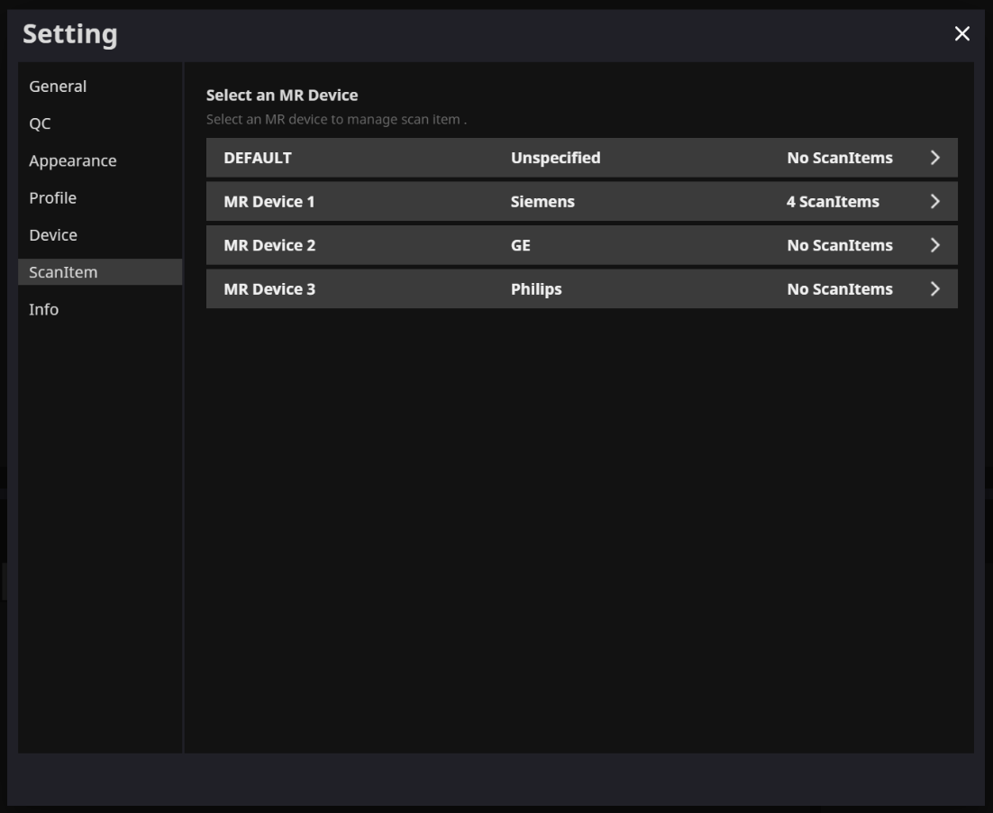

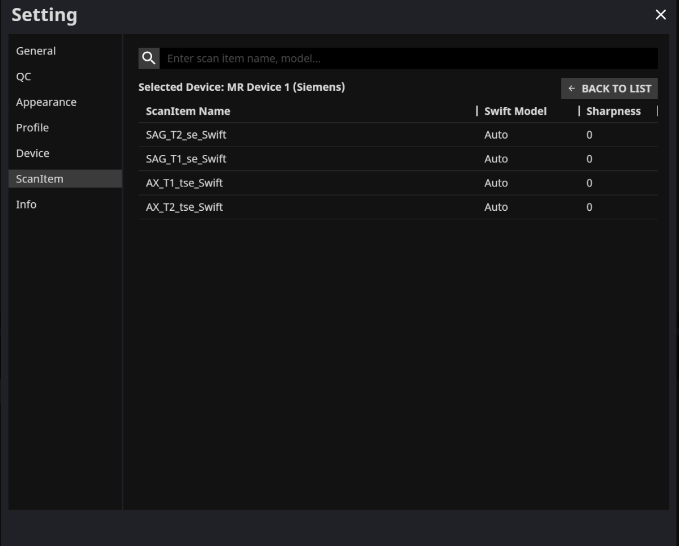

|  |  |
| --- | --- |
|  | Caution: If the input MR images were not obtained with the recommended MR imaging settings, there may be performance degradation in the resulting processed images. |

### Info Settings

Users can view user manual, information of the license in use, software information, and manufacturer information by clicking on the **S/W Info** ( ) button or from the Info tab of Settings.

In addition, the user can view the usage period information and maximum usage information.

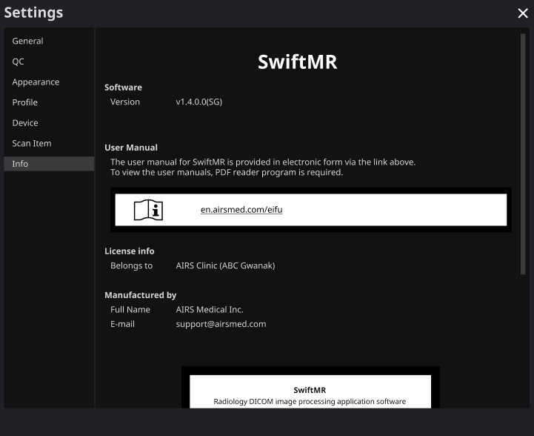

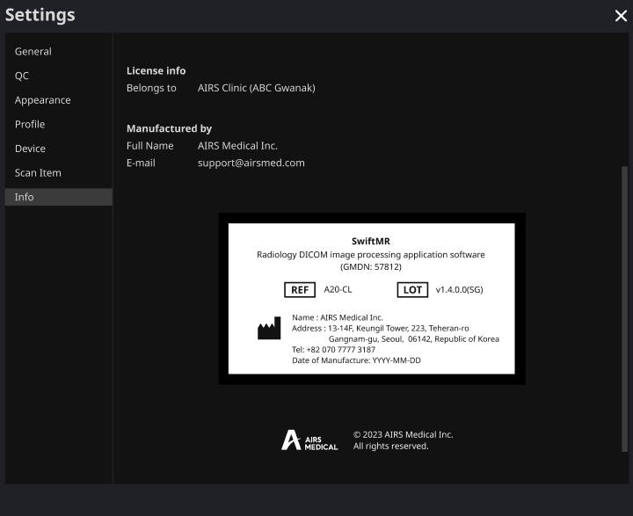

# User Account Management

Passwords of user accounts can be changed in their profile settings (refer to Section 2.7.4). If you want to create a new user account or modify the basic information of an existing user account, please contact Customer Support ([support@airsmed.com](mailto:cs@airsmed.com)).

# MR Scans and Image Processing

If you have completed the establishment of the settings to be suitable for the institution’s circumstances by following the instructions of Section 2, you can now receive processed images by using SwiftMR.

## MRI Scans

The imaging is performed using the MRI scan protocols provided by the manufacturer. Before scanning, select the appropriate MR Device in ‘Settings → Protocol’ from the Client Application, check whether the protocol name for the scan is registered and displayed on the UI, and then proceed with the MRI scan. When the scan is finished, the images are sent to the SwiftMR server through a specified path.

## Image Processing

When images are received at the SwiftMR server, image processing is conducted using SwiftMR's deep learning model. The processed images are automatically saved in PACS in the form of DICOM files, and they can be saved as a new series in an existing study, or as an independent study that can be created and saved in PACS. The preference of this option will be defined during the discussion between the institution and the manufacturer prior to the contract.  
  
When image processing is completed, this can be informed through a notification from the Client Application. SwiftMR does not provide a viewer program, so please use the existing DICOM image viewer used by the institution for viewing the images.

# Cybersecurity

In order to ensure the cybersecurity of medical devices, SwiftMR meets the requirements of availability, confidentiality and integrity as follows.

* **Availability** implies that data should be readily available to an authorized user in the required format, whenever or wherever it is required.
* **Confidentiality** implies that data is not disclosed to an unauthorized person and is not used for unauthorized purposes. Even if data is disclosed by illegal methods such as an unauthorized inquiry or errors during data transmission/reception, SwiftMR makes it difficult to decrypt data through effective encryption and only allows authorized users to access the data. It also limits the range of data access according to the purpose and privileges of data users.
* **Integrity** implies that data is not altered or destroyed in any unauthorized manner. All information handled by SwiftMR should be accurate and complete, and the cybersecurity system of SwiftMR protects data from being distorted due to forgery or falsification. In addition, SwiftMR only allows authorized users to amend data handled in the system, and also manages logs and change history.

Before installing and running SwiftMR, cybersecurity procedures must be performed according to the following guideline. The following guideline will help you protect this software from cybersecurity threats such as virus or breaches.

* Prior to installing and running SwiftMR, run a reliable anti-virus program to prevent data corruption from viruses.
* Keep your anti-virus software up-to-date.
* Confirm that the latest security updates are applied to your OS.
* Activate your PC’s firewall. Windows 10 or above is equipped with a built-in firewall.
* SwiftMR has the highest possible security settings selected by default.
* When there is a new update, Users can choose whether to perform the update or not.
* When a forced update is required due to security issues or critical bugs, software update is mandatory. If not updated in a timely manner, the software may not function properly.
* When the software’s cybersecurity has been compromised, AIRS Medical can disconnect the applicable network (VPN, TLS Proxy, etc.) to protect critical functionalities and data.
* The main settings required to operate SwiftMR are stored in the DICOM Control Server. Therefore, even if a problem occurs in the client application, and reinstallation is performed, the main settings are maintained for intact product operation. The database files of the DICOM Control Server are also backed up, and thus in case of an error emergence, the backed-up database files can be restored to make the product operational.
* Even if a temporary error occurs while using the Client Application, image processing will still operate normally, due to the functioning server programs. DICOM Control Server turns off when the PC shuts down, but it automatically is executed when the PC is turned on again. The images that had not been processed during the time the DICOM Control Server was turned off, will be processed once they are resent to the server. In case of the server programs, uninterrupted operation is guaranteed via automatic restart or executing multiple instances during server shut down.
* Checksum validation is performed each time the SwiftMR application is executed, or when an update is conducted. Through this, the integrity check is performed, and if it is determined that there is a problem in the results, the program will automatically be terminated. In this case, please delete and reinstall the application or contact Customer Support ([support@airsmed.com](mailto:support@airsmed.com)).
* AIRS Medical is not responsible for accidents caused by not complying with the above instructions.

If you have any concerns or issues related to cybersecurity, use the phone number and email address listed at the last page to contact Customer Support.

If you have any issues related to cybersecurity, please contact Customer Support ([support@airsmed.com](mailto:cs@airsmed.com)).

# Trouble Shooting

If you have any problem that cannot be resolved through this user manual, please contact Customer Support ([support@airsmed.com](mailto:cs@airsmed.com)).

| Category | Symptom | Cause & Measure |
| --- | --- | --- |
| Integrity anomaly | “Integrity test failed” message shows up and SwiftMR service is not executed. | Part of the installation files may be damaged or lost. Reinstall the program or contact the manufacturer. |
| Network Connection | Network connection  status icon is | This indicates that there is a communication problem between the hospital network and the SwiftMR cloud server. This may cause problems in image processing, thus contact **AIRS Medical** or the manufacturer. |
| Automatically logged out even when the set time for automatic logout has not elapsed. | There may be a problem with the Internet connection of the PC where the Client Application is installed. Check the Internet connection of your PC. |
| Worklist Synchronization | MR images that have been scanned are not imported into the SwiftMR worklist | This may be because the applicable MR Device is not connected to SwiftMR. Check the device settings at [Settings → Device]. |
| This may be because the Protocol Name used in the MR scan is different from the one registered in the protocol settings. Check the protocol settings at [Settings → Protocol]. |

|  |  |
| --- | --- |
|  | Caution: All activity and system logs of SwiftMR are stored and archived. |

# Maintenance

Before using SwiftMR, please check to see if Daily QC has been completed successfully. When a problem is detected during use, the system will utilize the latest QC logs for conducting an abnormality check.

To fix bugs and to update image processing algorithms, it is recommended to upgrade the product at least once a year.

* In the case of the Cloud type model (A20-CL), all updates and upgrades are performed automatically on the server, so you can utilize the most up-to-date performance.

# Quality Assurance

AIRS Medical Inc. warrants against defects in the design and production process during the warranty period of 1 year from the date of receipt of the product by the customer. In the event of a dispute, it will be proceeded in accordance with the Fair Trade Commission’s settlements of consumer disputes.

AIRS Medical Inc. does not guarantee the following items:

* Damage caused by external factors such as accidents, misuse, fire, earthquake, etc.
* Modified products without the written consent of AIRS Medical Inc.
* Damage caused by service performed by an engineer or service provider not authorized by AIRS Medical Inc.

Before requesting a warranty service, please refer to the contents of this user manual first, and then contact us through Customer Support.

* Customer Support: [support@airsmed.com](mailto:support@airsmed.com)



**AIRS Medical Inc.**13-14F, Keungil Tower, 223, Teheran-ro, Gangnam-gu, Seoul, 06142, Republic of Korea

[www.airsmed.com](http://www.airsmed.com)

[support@airsmed.com](mailto:cs@airsmed.com)